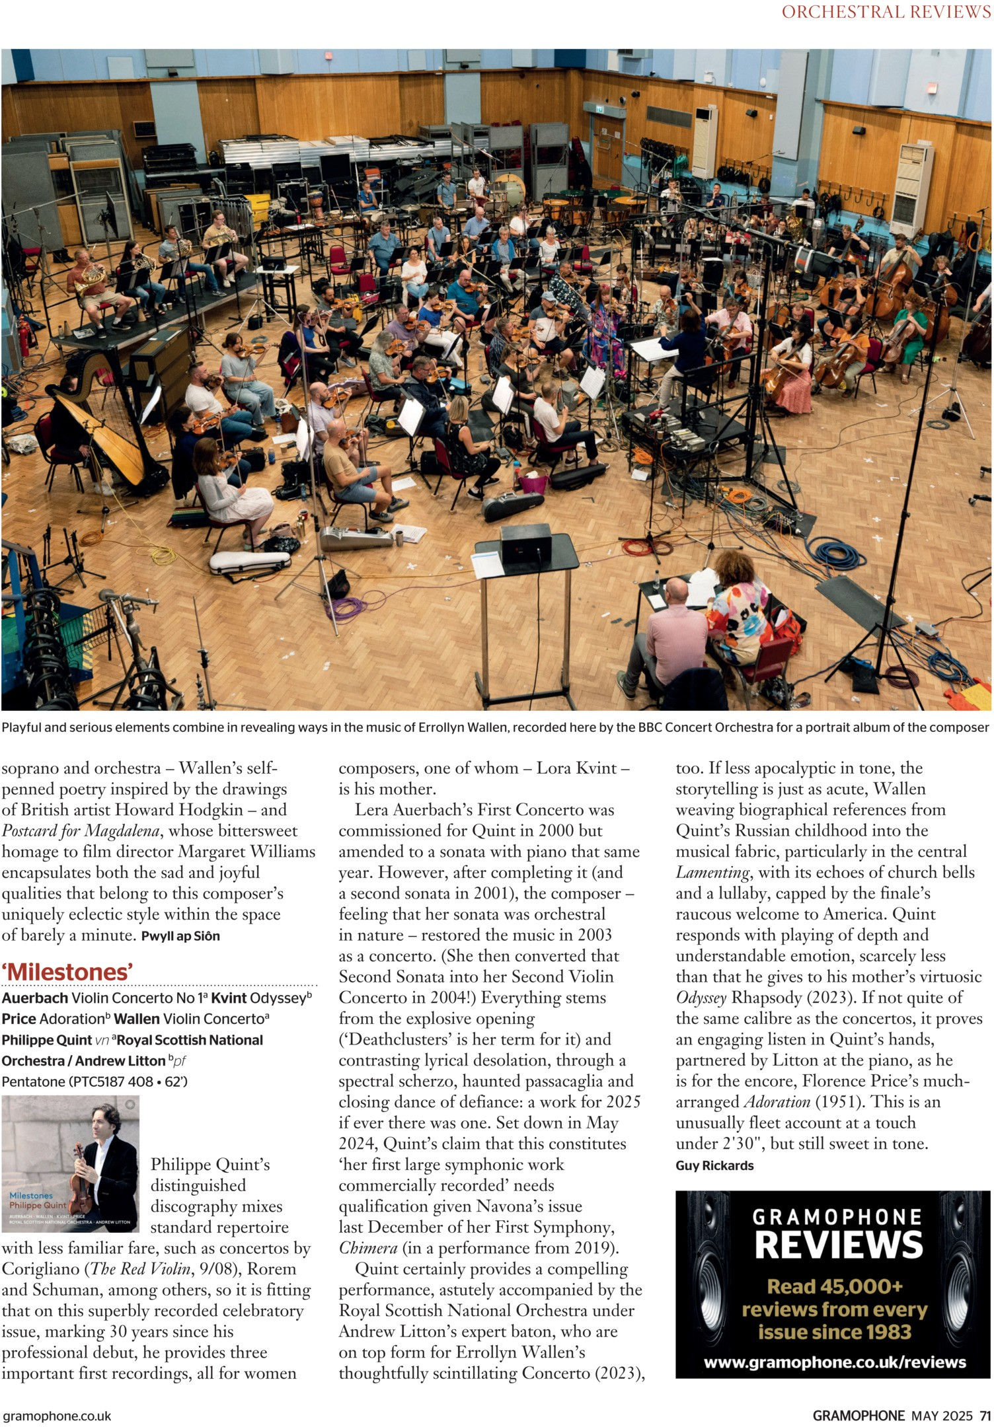

Printed for paula.mlyn from Gramophone - May 2025 at exacteditions.com. Copyright © 2025

